Animal Town

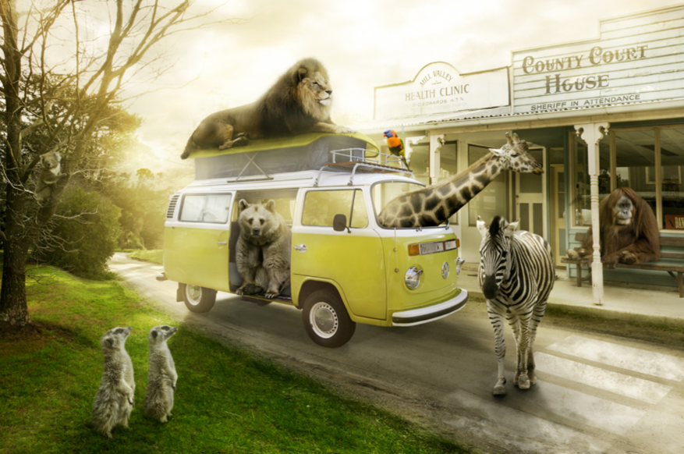

Sick Sentences

Can you make these sentences better?

A lion sat on the van.

A giraffe put his head out through the window.

The zebra walked across the road.

Perfect Picture

Can you draw and label a picture of what you think it looks like inside the supermarket in Animal Town?

Challenge

Can you write a story about Animal Town?

