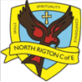 WE ARE ARTISTS
Class: Apples Teacher: CD Term and Year: Autumn 2020
PRIMARY PROVOCATION

“All superheroes wear capes”
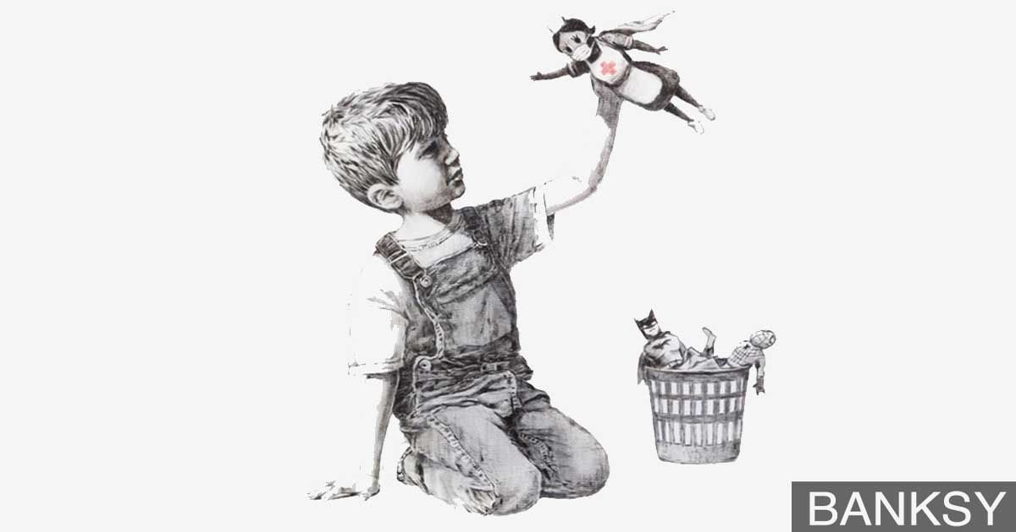

THE ROOTS OF TEACHING FOR LEARNING
These are the prerequisites of Teaching for Learning

constant feedback from all adults
sustained shared thinking between adults and children, between children
continuous questioning and hypothesising
high expectations for all
valuing every person and every contribution
learning from mistakes
recognising and celebrating achievements
willingness to be brave

Teaching for Learning is rooted in our values. In WE ARE ARTISTS we are focusing on the following values.
RESPECT  As part of our settling in process we will discuss how to respect our resources and each other. There will be a strong focus on respecting the art and music resources which are available and the views/feelings of others.  As the project progresses, we will learn how to respect those in our community and the contribution they make. | COMPASSION  This whole project is rooted in compassion for others – how we show it, how we accept it and why it is important.  We will see that all superheroes (real or fictional) show compassion to others and that this leads their actions.  It is a vital element to being a hero.

THE TRUNK OF TEACHING FOR LEARNING
Teaching for Learning Objectives | Activities to Support Teaching for Learning
 | What are the adults doing? | What are the children doing?
Art:  - What happens when they mix colours  - How different media can be combined to create new effects such as texture  - How to use simple tools such as scissors, paint brushes, glue sticks  - How to use simple techniques to shape materials (cutting, folding, joining)  Music:  - the names of different instruments, how to play them and what they sound like  - The structure of a song including verse, chorus and rhymes  - Differences in tempo, pitch and volume | - Introduce a routine to the day  - Introduce the different areas of the classroom (inside and out) with expectations, rules, boundaries etc  - Model how to use the workshop appropriately, the names of the different resources  - Introduce different instruments that they will have access to, how to look after them and use them appropriately  - Explore ways to use the instruments alongside nursery rhymes to link to phonic teaching  - Introduce different styles of art work – Banksy pencil drawing, cartoon work, clothes design  - Introduce how films etc portray heroes vs baddies using music | Engaging in the routine for the day – coming into school and putting away their belongings, engaging in productive play, knowing when to sit on the carpet (and how)  - Exploring the resources and how to use them  - Learning to respect resources and tidy up appropriately  - Visit the workshop to work with an adult to learn where resources are and how to access/use them and tidy up afterwards  - Explore cutting, sticking, colour and texture  - Explore colours and how they can be used, including mixing  - Know which part is the verse and which is the chorus and identify some of the themes and rhymes eg ‘wheels on the bus’ and ‘Superman’  - Engage in lessons introducing and using instruments – begin to use and name them in their play  - Follow rhythms and patterns when using the instruments alongside familiar songs and rhymes  - Know some of the repetition and rhyme in familiar stories and nursery rhymes  - Cut, stick and paint to make cartoons, costumes and story boards of their heroes

GROWING
The child is beginning to demonstrate understanding and is engaging with the learning. They recall some knowledge and use some vocabulary correctly and in context but maybe not sufficiently confident to do this without prompting. They are carefully led, by the adult, through small steps of guided learning to recognise, practise and repeat key skills.
Teaching for Learning Objectives | Activities to Support Teaching for Learning
 | What are the adults doing? | What are the children doing?
ART  - Explore what happens when they mix colours and create different textures  - Manipulate materials to a planned effect  - Use simple tools and techniques competently and appropriately to engage in drawing, painting, printing, 3-d, collage and textile work  - Select appropriate resources and adapt work where necessary  - Know the work of John Stango, DC comics, Banksy, DaVinci  MUSIC  - Build a repertoire of songs and dances  - Explore the different sounds of instruments  - Begin to play instruments or body percussion with control including different tempo, pitch and volume  - Listen with attention to different styles of music and respond appropriately | What does a superhero look like?  - Mind map with the children what they think a superhero is  - Read stories such as the Supertato series  - Look at the work of artists such as John Stango and comics such as DC  - Listen to theme tunes from different superhero films  - Model designing own theme tune for a personal hero  Who are our superheroes?  - Relate the term hero to community and essential workers  - Explore Banksy hospital art  - Model cartoon art of key workers  - Model making a theme tune for key workers | What does a superhero look like?  - Think about their experiences of super heroes – what they do, look like etc  - Role play being a superhero  - Exploring the values and emotions of superheroes  - Looking at art work of superheroes  - Listening to music which expresses hero acts  Who are our superheroes?  - Relate the term hero to normal people who show high levels of compassion and respect  - Understand/respond to the Banksy artwork  - Create cartoon art and theme tunes for our own heroes
BLOSSOMING
The child is engaged and enjoying the learning and able to apply the necessary skills and knowledge in order to demonstrate their understanding of the learning. They confidently meet the objectives and demonstrate a full ability to use the vocabulary correctly and in context. They are confident when making links and explaining their method to others. They are encouraged to explore and experiment whilst the adult sets challenges, hypothesises and explores misconceptions with them.
Teaching for Learning Objectives | Activities to Support Teaching for Learning
 | What are the adults doing? | What are the children doing?
ART  - Select tools and techniques needed to shape, assemble and join materials they are using  - Plan their own work incorporating ideas linked to projects  - Represent their own ideas, thoughts and feelings through art and design  MUSIC  - Represent their own thoughts and feelings when playing and creating music  - Use music to accompany stories  - Listen to different styles of music and discuss how they make them feel | What does a superhero look like?  - Create superhero den, writing area and physical workout area  - Introduce and share different images of superheroes  - Provide resources to make props and costumes for superheroes  - Share different theme tunes for heroes (eg film scores) and provide resources to create their own  - Model cartoon storyboards  - Create areas in finger gym, water to explore resilience and perseverance  - Link our school values to hero values  Who are our superheroes?  - Introduce Banksy art and explore how it is different to cartoon art  - Set up hospital, bus stop and shops for role play  - Model role playing eg doctors as a type of hero based on previous learning  - Provide resources to design and create hero costumes for familiar people  - Introduce vocabulary to describe them – why does a particular colour show what they do? Why have you chosen to give them eg a cape?  - Provide resources to adapt familiar songs and create theme tunes for familiar people. | What does a superhero look like?  - Role play being a superhero indoors and out  - Talk about what a hero looks like in cartoons, films and books – create paintings and drawings  - Design and create their own costumes and props to support role play  - Use vocabulary or colour, shape and pattern in their play as they describe their costumes and create storyboards  - Explore hero theme tunes and create their own using percussion instruments. Explore the use of tempo and volume to create atmosphere.  - Apply vocabulary and understanding to other areas such as finger gym activities through storytelling and songs.  Who are our superheroes?  - Create paintings, models and props in the style of cartoons to depict familiar people as heroes  - Role play eg doctors etc using vocabulary previously taught  - Design and create costumes and props for our own heroes  - Be able to explain why their model/painting has certain colours, patterns and shapes to show different skills or qualities  - Sing familiar songs and accompany with percussion – adapt some songs to fit their play
FLOURISHING
The child is exhibiting a depth of learning and enthusiasm relating to the objectives. They can select knowledge and understanding for different contexts and justify their choice when using their repertoire of skills. They are able to revise, review and reflect on what they know and create their own solutions to situations, justifying the rationale for what they are demonstrating. They are able to, and indeed want to, ‘show off’ with what they know and what they can do; they want to share that they are flourishing and how they know they are flourishing. Adults are present for affirmation and organisation.
Teaching for Learning Objectives | Activities to Support Teaching for Learning
 | What are the adults doing? | What are the children doing?
Children develop their own ideas through selecting and using materials and working on processes that interest them. Through their explorations they find out and make decisions about how media and materials can be combined and changed.  Children talk about the ideas and processes which have led them to make music, designs, images or products. They can talk about features of their own and others’ work, recognising the differences between them and the strengths of others. | Observing play and scaffolding learning by providing additional resources in response to interests.  Organising additional activities and affirming flourishing by sharing with the class/other teachers. | Taking the vocabulary and understanding of our school values into their play by using key language and explaining through talk or actions.  Choosing specific aspects of creative arts to demonstrate their understanding of what a hero is and why they have chosen to represent them in a particular way.  Making links and comparisons to artistic styles (cartoon and Banksy) and musical accompaniments (theme tunes) to their own creations.  Creating their own props to enhance role play; developing their own storylines and themes.
WE ARE ARTISTS
Class: Apples Teacher: CD Term and Year: Autumn 2020
FINAL FLOURISH
The children will use their learning to design their own superhero.
They will design a costume for them and create it, paint the hero and make a potato model. With help from an adult they will make labels to show the special skills and qualities the hero has.
As a group we will make a superhero theme tune.
The children will make a video of them showing their work and explaining why they have chosen certain features. Each video will be accompanied by the class theme tune and posted for the parents to view.

