First Aid Kit
Wellbeing and activity ideas

Here is a great way to keep reading your favourite books  https://home.oxfordowl.co.uk/reading/free-ebooks/ | Here are some mindfulness activities for children  https://positivepsychology.com/mindfulness-for-children-kids-activities/ | Cosmic yoga  https://www.cosmickids.com/category/watch/
Can you find some interesting boxes and cartons in your recycling box?  What can you make from them? Perhaps a house for a toy, a garage for your cars, a treasure box for your special objects or just a beautiful sculpture!  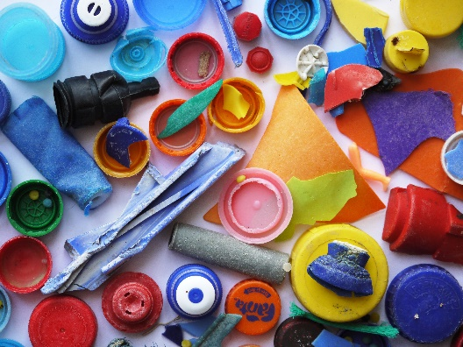 | Choose your favourite story – can you inspire your toys to be actors and put on a show for the grown-ups in your house?  I would love to see a video of your work!  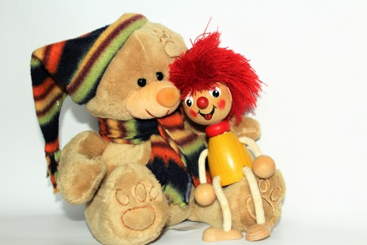 | Can you go on a leaf scavenger hunt?  Make a list of different leaves and see what you can find – here are some ideas:  Sharp, flat, bumpy, crumbly, rough, smooth, shiny, dull, speckly, stripy, multi-coloured, beautiful  What else can you find?  You could collect some leaves and make some beautiful artwork from them.
Useful websites:
CBeebies Numberblocks:
https://www.bbc.co.uk/iplayer/episode/b08bzzns/numberblocks-series-1-one
CBeebies Alphablocks:
https://www.bbc.co.uk/iplayer/episode/p0872x41/alphablocks-magic-words-1-meet-alphablock-a
Oak Academy:
https://classroom.thenational.academy/schedule-by-year#schedule
Phonicsplay:
https://www.phonicsplay.co.uk/

