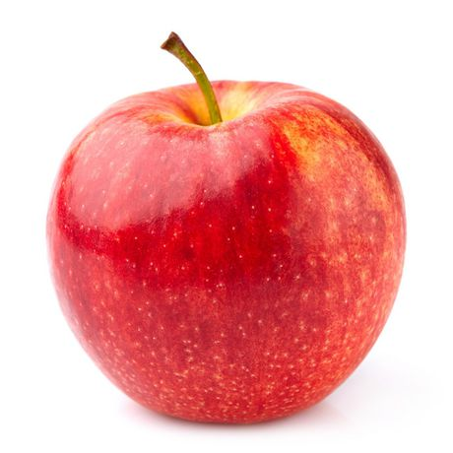
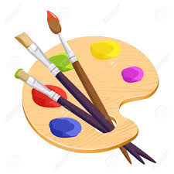
Apples Class
Autumn 1 Learning Opportunities
“We Are Artists: Superheroes”

Here are a variety of different activities which you may wish to do with your child at home; please keep the learning log at home to enjoy as a family. You can complete the tasks in any order when inspiration takes you
This page is designed to help families to Enjoy Learning Together at Home. I would be delighted if you could return the book to me at the end of each half term so that I can look at all of your work.
We also encourage children to read as much as possible at North Rigton. Please sign the reading log when you have heard your child read.
Phonics/Spelling:  You could help your child at home by using the RWI Sound Book for the sounds we are covering this term. Keep an eye on the weekly letter for which sounds we are covering and fun ideas to practice the skills we are learning in class | Mental Maths:  Keep an eye on the weekly letter for fun ideas to practice the skills we are learning in class. | Reading:  Please try to read as often as you can at home with your family.  With the current restrictions I will send home books on a Monday to be returned on Friday for disinfecting. | Writing:  You could help your child at home by encouraging them to write cards, messages, lists and stories.  They may wish to use bubble writing, the computer or even cut letters out of magazines to form their letters in different fonts. | Free Websites:  There are some fantastic free interactive websites for English and Maths which can be used on the iPad or computer. You may wish to enjoy using them together:  Topmarks  https://www.topmarks.co.uk  ICT Games  https://www.ictgames.com  BBC Numberblocks  https://www.bbc.co.uk/cbeebies  /shows/numberblocks  Phonicsplay (some games are free and others available for a small charge) https://www.phonicsplay.co.uk/freeIndex.htm
Project:  Who is your favourite superhero?  You could paint or draw a picture or find some pictures in magazines or on the internet.  Can you explain what skills make them super and why they are a hero?  You could ask a grown up to help you write your ideas down. | Project:  Can you listen to some superhero music?  (for example, theme tunes from films).  How does the music make you feel?  You could draw a picture of how you feel and ask a grown up to help you write the words.  Some children might like to create a dance or make their own music – you could put it onto Tapestry for me. | Project:  In class we will be learning about “Supertato” (Sue Hendra) and making our own potato models.  Can you make a super veggie?  You could take a photograph to stick in your book and write down what makes it super and a hero. | Project:  Superheroes need to stay healthy.  Can you design a healthy meal, menu or shopping list for your hero? You could even make a superhero meal for your family and take a photograph.  Can you have fun doing some superhero exercises?

