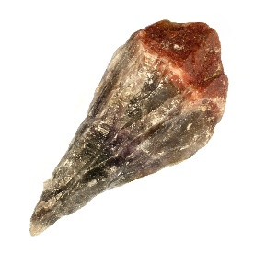

A and G’s 500 word or more Essay.
The Volcanic Crystal
Hi my name’s A and this is my friend G
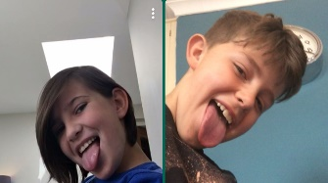

We don’t let many people see our faces, for we don’t want people to tell our enemies our true identity.
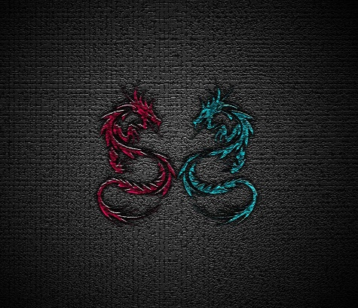
This is our super logo, do you like it? We are known as The Corrupters.
Our secret base is inside at the bottom of a very, very, very old volcano that hasn’t erupted for centuries. By our side we have two trusty dogs called Elsie and Stella. We have a lot of different rooms including our weaponry room, a football pitch room, our dogs room and a swimming pool hangout room with a hot tub, which we use for hanging out with our friends. Oh and the post just came. It says
‘Dear The Corrupters
I have been meaning to remind you about our battle 5 years ago when I stole the volcanic crystal. I wanted to warn you that I am going to use it to destroy the world by making volcanos appear and erupting them. To stop me you will have to come to my castle on Saturday at 10pm sharp.
Yours sincerely
Shazooka.’…

Right then, its Friday and I’m going off to bed and getting an early start, since it’s already 9pm. In 13 hours it’ll be 10am, so we should get ready then. I know it sounds crazy to go to your enemies castle at 10:pm and all, but it’s kind of how it works here, so we’re used to it.
13 hours later. Alright, in 12 hours it will be 10pm so I am getting ready now, but it could be a trap so we should be prepared. Let’s go to our weaponry room and get some big guns, because we know he has deadly army troops. We should get some rocket launchers, grenades and spit balls for distractions.
12 hours later. Are you ready to go up the lift up to his castle? Let’s go. Tut, tut, tut, this lift really needs fixing it’s so slow. Finally, we’re here. Let’s knock. Knock, knock, knock. Come in, you’re one second late! I really asked you here for a fight. Mwah ha ha ha. I knew it was a trick. Luckily we have brought weapons, he he. The battle begins. Haaaaaaaaaaaaaaahhhhhhhh!!!!!!!!!! Whoa! Look at that sword, it’s the clown knife sword that you can only get if you kill killer clown or pennywise. I remember hearing pennywise die on the news. Why would they care about pennywise? He’s a bad guy. Less talking, more fighting! Wait, this is pretty easy, just push him into the lava. Corner him! Ahhhhhhhhhhhh. Well he’s a gonner! But we still have to fight the army troops and get the volcanic rock. Wow, there’s a lot more of them than I expected. Yeah, there’s loads of them. Just get our rocket launcher out, that’ll surely kill them all and blast the rest into lava. Let’s go! Bam! Well, they’re all gonners. Right, now it’s time for the crystal. Let’s go get it. I can’t believe he doesn’t have any guards… wait, he does have lasers, we’d better be careful, let’s go. That was easy, right back to base now? Ya! Once again we have saved the world! Woo hoo!

This story was made possible by Whereby,
thanks Whereby!
And our parents for letting us do it!

