Foxes
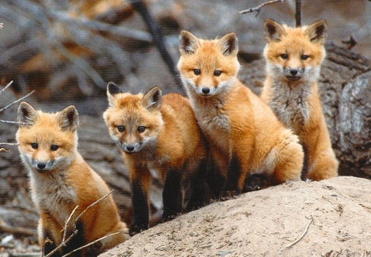

By Imogen T

Content
- Foxes
- Red Foxes
- Arctic Foxes
- Fennec Foxes
- Glossary

Foxes
A fox’s main diet is rodents and small animals but their diet can be flexible as they will eat fruit and invertebrates. They are omnivorous animals with upright triangular ears, a slightly upturned snout, a flattened skull and a long bushy tail.
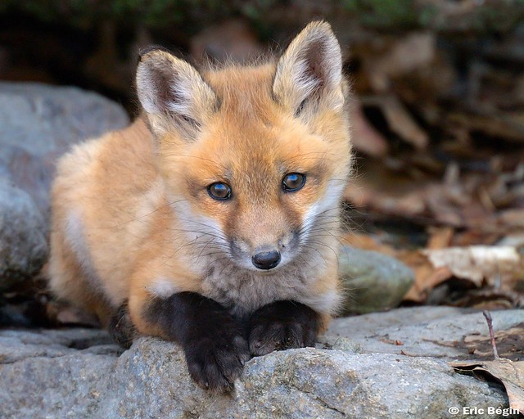

Red Foxes
Red foxes are the largest of the true foxes. They can be identified by the red colour of their fur. When in the wild, their lifespan is 2-5 years and their mass is 2.2-14kg (adult). You can often hear mating calls which is a high-pitched shrieking noise. They catch small rodents with a characteristic pounce. This hunting technique is one of the first things cubs learn as they begin to hunt.
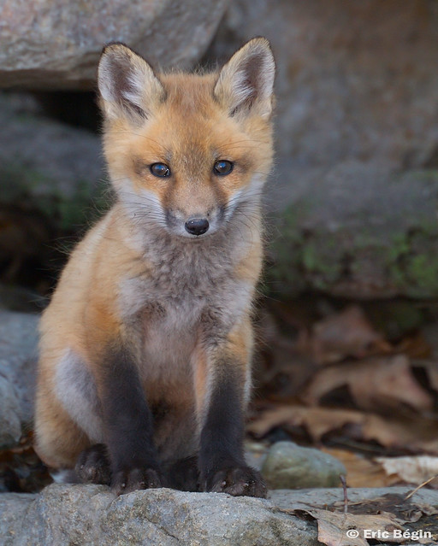

Arctic Foxes
The arctic fox, also known as the white fox, polar fox or the snow fox, is a small species native to the arctic region. The mass of an average male fox is 3.2-9.4kg and the average mass of a female is 1.4-3.2kg. In the wild, their average lifespan is 3-4 years whereas in captivity their average lifespan is 14 years.
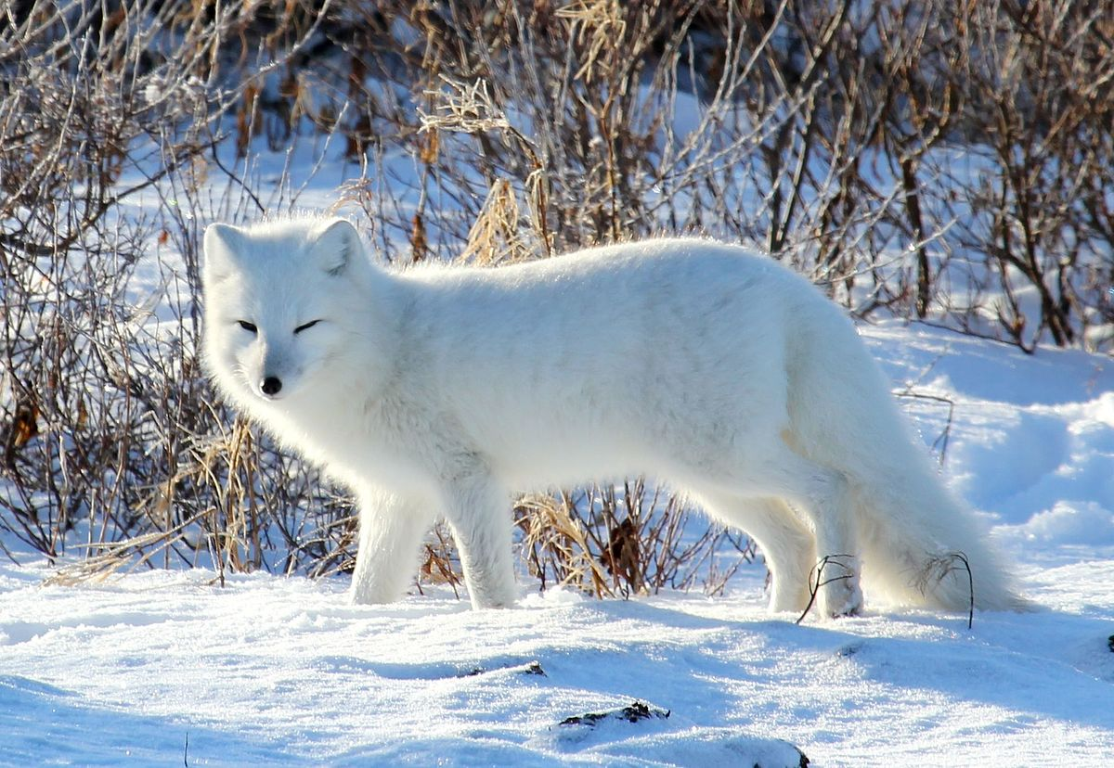
Fennec Foxes
The fennec fox is also known as a desert fox and weigh around 0.7-1.6kg. On average, they are 20.3 cm (8 inches) tall and 24-41 cm (9-16 inches) in body length. This species is found in North Africa and Asia. A fennec fox’s typical den is dug in the sand, either in open areas or places shaded by plants with stable sand dunes.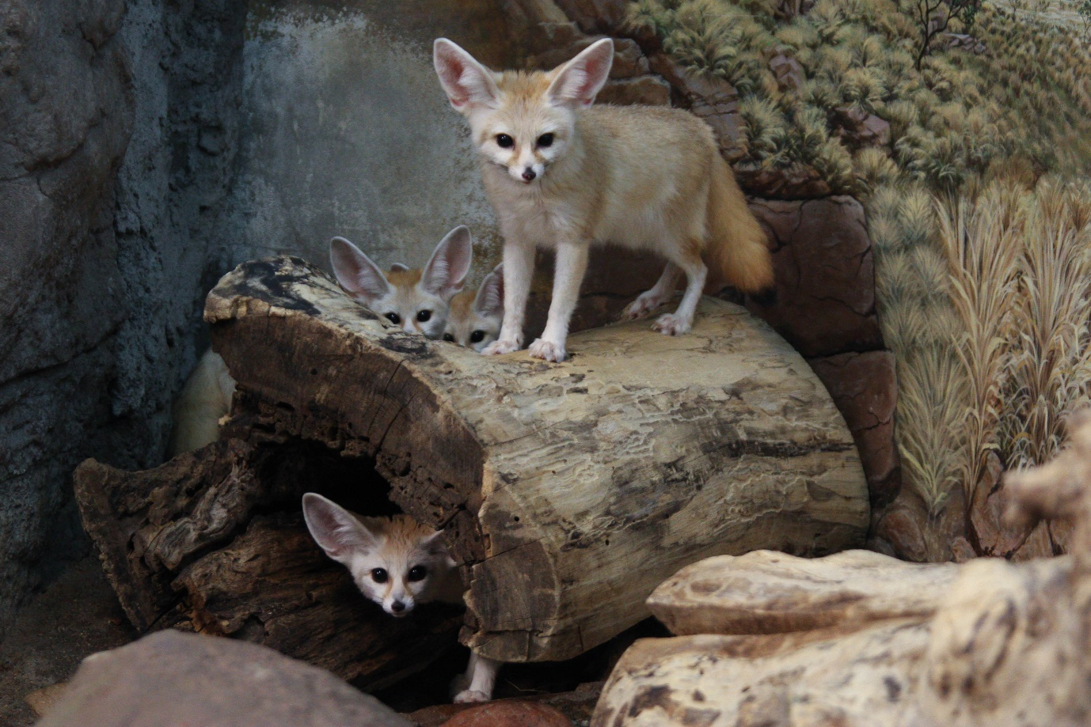

Glossary
- Average typical or most common
- Characteristic main or most important feature
- Diet what it eats
- Lifespan how long something lives
- Mass the weight of something
- Mating call the sound an animal makes when trying to find a mate
- Native originally from somewhere
- Omnivorous eats plants and meat
- Rodent small mammal
- Snout an animals nose
- Species a group of animals which are the same type
- Technique a style or method

