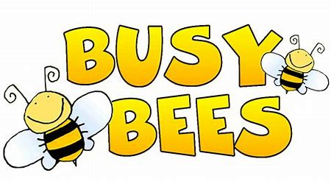
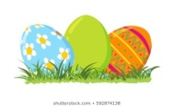Busy Bees Class Home Learning Grid 2 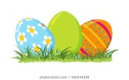
Easter Special!
Please also refer to the previous Home Learning Grids for websites and useful resources.
RE/ENGLISH  The Easter Story:  https://request.org.uk/festivals/holy-week-and-easter/the-easter-story-2/  Watch the following clips about the Easter Story.  Can you create a storyboard, using pictures and full sentences, to retell what happened?  You could then act it out and create your own play! Alternatively, you could make freeze frames of each part of the story and take photographs to share on the class website page. If there is no one to do it with you, you could use your toys. | MATHS  Please find below a LKS2 Easter Maths Home Learning Bumper pack with lots of activities to enjoy:  https://www.twinkl.co.uk/resource/t-tp-412-lks2-easter-maths-home-learning-bumper-pack-  Complete some Easter Maths Challenge cards:  https://www.twinkl.co.uk/resource/t2-m-17463-lks2-easter-maths-challenge-cards  https://www.twinkl.co.uk/resource/t2-m-2488-lks2-maths-reading-scales-easter-baking-challenge-cards  Have a go at this QR Code mathematical treasure hunt  https://www.twinkl.co.uk/resource/t2-m-17462-lks2-easter-maths-qr-code-treasure-hunt-activity-sheet  You may also consider doing the following:  - Setting up a maths themed Easter egg hunt around the garden. You could set up an orienteering course (with maps) like we have done in our PE lessons this term).  - Baking an Easter cake and weighing out the ingredients accurately. | ARTS AND CRAFTS  Can you have a go at creating some of these Easter craft ideas?  - Make Easter bonnets  - Decorate an Easter themed t-shirt  - Make some chocolate crispy Easter nests to enjoy (you could even write instructions and the recipe to explain what you did)  - Make this delicious No bake Mini Egg cheesecake  https://www.tamingtwins.com/mini-egg-cheesecake/  or Mini Egg Cookie bars https://www.bing.com/videos/search?q=mini+egg+cookies&docid=608043600633790852&mid=F99A15E5AA4D37F90568F99A15E5AA4D37F90568&view=detail&FORM=VIRE  - Create your own Easter garden (http://request.org.uk/restart/2017/02/23/make-an-easter-garden/)  - Make yourself an Easter Chick Paper model https://www.twinkl.co.uk/resource/t-t-17826-easter-chick-paper-model
WRITING  Poetry  Can you write an Easter poem? You could choose to write a nonsense poem (like we studied last term) with an Easter theme or write an Acrostic poem about the Easter Story or other things associated with Easter.  Non-fiction  Can you find out about how people celebrate Easter around the world and display your information in an interesting way – e.g. a 3D map, a booklet, a powerpoint. If any of the celebrations interest you, you could try it out e.g. making a huge omelette (in France they make one to feed 1000 people)  https://www.scholastic.com/parents/kids-activities-and-printables/activities-for-kids/holiday-and-seasonal-ideas/easter-traditions-around-world.html | SCHOOL COMPETITION  Can you decorate a hardboiled/blown egg in the theme of:  Eggcellent Entertainers!  When you have completed your design, please send a photo to your class teacher! Winners will be placed on the classroom pages of our website. Entries should be emailed before 20th April, please. | COMMUNITY PROJECT  Can you design and make a set of Easter cards to brighten the day of someone who may need some extra love sending their way? Think about people in our North Rigton community who may need a little bit of a boost and help to spread joy and happiness around our neighbourhood.  Or you could make a gigantic Easter card to put in your front window for everyone to see!

