Y3: Maths Home learning grid
If you would like to complete any of these challenges, please feel free to do them in your blue Numeracy books which have been sent home.
ROLL AND ADD  Roll a dice to create a three digit number. Do this twice.  Add up these numbers using column addition  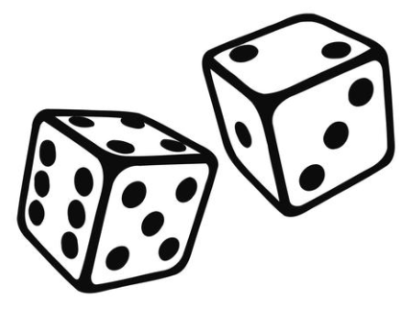 | PLAYING CARDS  Using a pack of playing cards. Split the pack in half with a friend. Turn a card over each. Multiply the numbers together. The quickest gets the cards. The winner is the one with the most cards at the end.  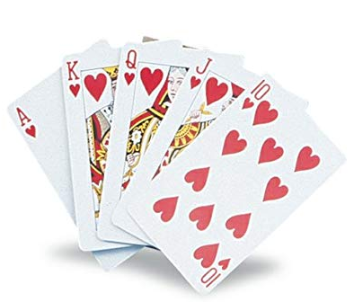 | MEASURING MADNESS  Use a tape measure/ruler to find an item in your house as close to these measurements?  10cm, 15cm, 25cm, 50cm, 1m  How close can you get?  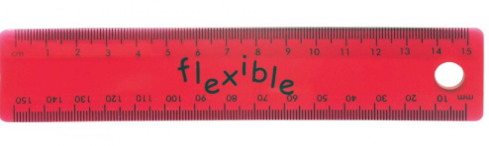 | ROLL AND SUBTRACT  Roll a dice to create a three digit number. Do this twice.  Subtract the smallest number from the largest number using column subtraction
WHATS THE PROBLEM?  Working with a partner- write down worded maths problems/stories for each other to solve- using addition and subtraction.  e.g. I have 39p in my purse. A chocolate bar costs 95p. How much more do I need? | AGE IS JUST A NUMBER  Write down the ages of all the people in your family.  - Order them  - Find the biggest difference between two of the ages.  - Find the smallest difference between two of the ages.  - Find the total of all ages | WHATS THE PATTERN?  Write out your times tables?.  3 and 6 tables  2, 4 and 8 tables  5 and 10 tables.  What is the link between them?  Show the patterns using a diagram. | SHOPPING LIST  Find the ingredients to make your favourite meal.  Price up how much it would cost to make the meal for a family of 4.  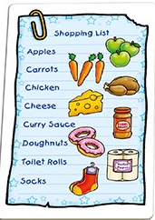
WHAT’S A-COOKING?  Using a recipe book. Choose a recipe you like the look of.  Can you work out the quantities for different amounts of people:  2 people, 4 people, 6 people, 10 people | TELLING THE TIME  Being able to tell the time is a very important skill! In Year 3 we learn to tell time to 5 minute intervals on analogue clocks. Ext. Can you convert it to digital as well?  https://www.topmarks.co.uk/Search.aspx?q=telling+time | HOW DO YOU DO IT?  Create a how to booklet to explain the different methods of addition, subtraction and multiplication to a younger pupil.  Remember to include:  Diagrams, arrays, place value charts, base ten, place value counters, number lines, formal written methods. | TIMES TABLES  Practise your X tables on TTRockstars or in the X table books that were sent home.

