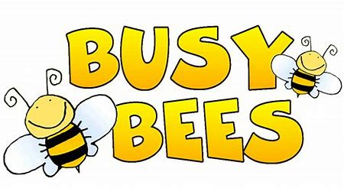
Busy Bees Class
Home Learning: Useful Websites

Please find below a list of websites for Maths and English which may be useful to use during the time in which schools are closed. All of the websites listed below are free to use and enjoy.
Maths
- https://ttrockstars.com/ - TTRockstars. Perfect for times table and arithmetic practice. All children have log in details which can be found in their orange ‘Enjoying Learning Together at Home’ books.
- https://play.numbots.com/#/intro - Numbots. Free trial until 27th April – use TTRockstars log in and password. Addition and Subtraction and key recall.
- https://www.oxfordowl.co.uk/welcome-back/for-home/reading-owl/maths - Oxford Owl Maths Page. Online activities, games and videos to support maths fluency.
- https://www.twinkl.co.uk/ - Twinkl. Sign up for free to access a range of worksheets and activities to support consolidation.
- https://www.timestables.co.uk/ - Times Tables. Another website to aid understanding of times tables.
- https://www.topmarks.co.uk/ - TopMarks. Interactive maths games.
- https://www.topmarks.co.uk/maths-games/hit-the-button - Hit the Button. A particularly useful game for key number skills.
- https://whiterosemaths.com/homelearning/ - White Rose Maths. This is what we use regularly in our school maths lessons. Lots of free resources and problem solving tasks.
- https://classroomsecrets.co.uk/free-home-learning-packs/ - Classroom Secrets. A range of free home learning packs to download.
- https://www.teachactive.org/2020/03/teach-active-homework-free-for-parents/ - Teach Active. Active maths lessons with free downloadable home learning activities.
- https://nrich.maths.org/9084 A great website for maths based problems. Just simply select the area of maths you want to focus on and narrow down the options to the age range.

English
- https://www.oxfordowl.co.uk/for-home/ - Oxford Owl. A range of free e-books along with games and resources to support early reading and phonics.
- https://www.twinkl.co.uk/ - Twinkl. Sign up for free to access a range of worksheets and activities to support consolidation.
- https://www.literacyshed.com/home.html - Literacy Shed. Full of videos and pictures to inspire writing. Under each picture/video there are creative writing ideas.
- http://www.pobble365.com/ - Pobble365. A picture a day to inspire writing. Under each picture there are story starters and creative writing ideas.
- https://www.oxfordowl.co.uk/for-home/find-a-book/library-page/ - Oxford Owl. Free ebooks for children.
- https://clubs-kids.scholastic.co.uk/ - A selection of authors to discover and enjoy.
- https://www.onceuponapicture.co.uk/ A picture a day to generate discussion and as a prompt for writing.
- https://www.poetryfoundation.org/poems/browse#page=1&sort_by=recently_added&filter_poetry_children=1 A website full of poems to read, perform and enjoy
- https://thinkwritten.com/writing-prompts-for-kids/ A great selection of writing prompts to inspire writing
- https://www.teachhandwriting.co.uk/continuous-cursive-joins-choice-3.html Handwriting resources
- https://www.phonicsplay.co.uk/ Lots of games to help children practise their phonics.
- https://spellingframe.co.uk/ Resources to help you to learn the Year 3 and 4 spelling patterns
- https://northrigton.typingclub.com/ Touch Typing – use your existing username and password

Twinkl Home Learning Packs
On this website there are lots of home learning packs and support available to download.
https://www.twinkl.co.uk/resources/keystage2-ks2/ks2-class-management/school-closure-home-learning-classroom-management-key-stage-2-year-3-4-5-6

