Designing sports wear
Chosen sport – swimming
Material – nylon with lycra so that it is waterproof, stretchy, lightweight and tight fitting.
Design –Tankini
Very colourful fabric to make sure it is bright and stands out. I am going to add a frilly pit on the neck line.
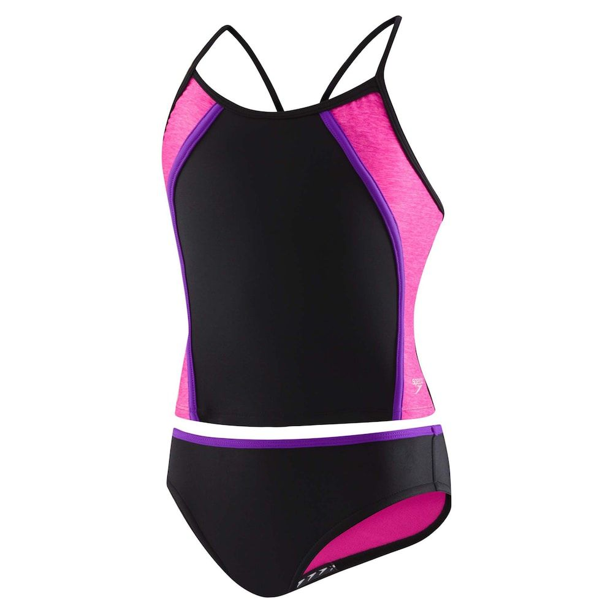

By Beatrix

